Jira workspace
- Firstly, we have to login into our account with our Gmail account and then we see home page like this.
- Click on create.
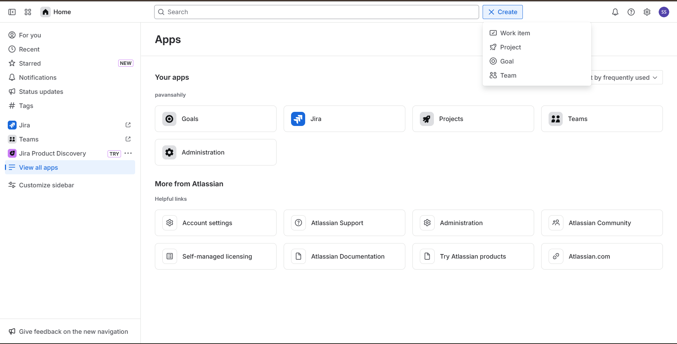

- Create team by adding ‘team name’, ‘team member’ .

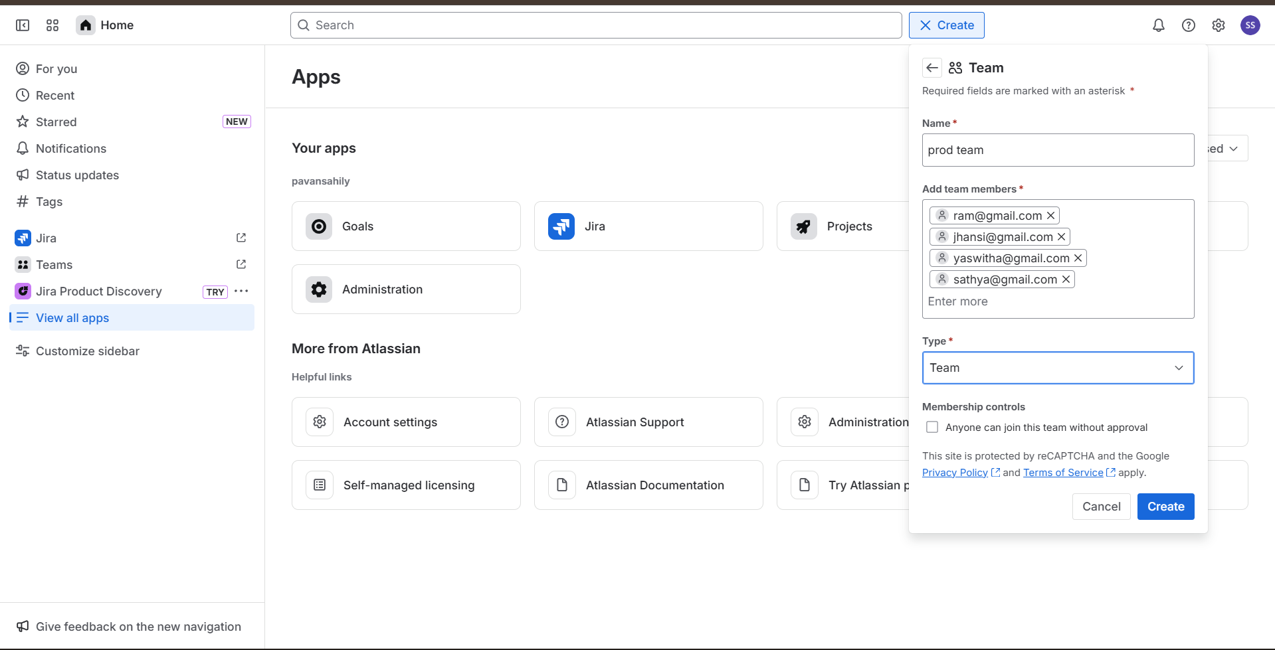
- Create different types of teams like ‘dev team’, ‘QA team’, ‘stag team’, ‘prod team’.

- Then we have to create a work item.
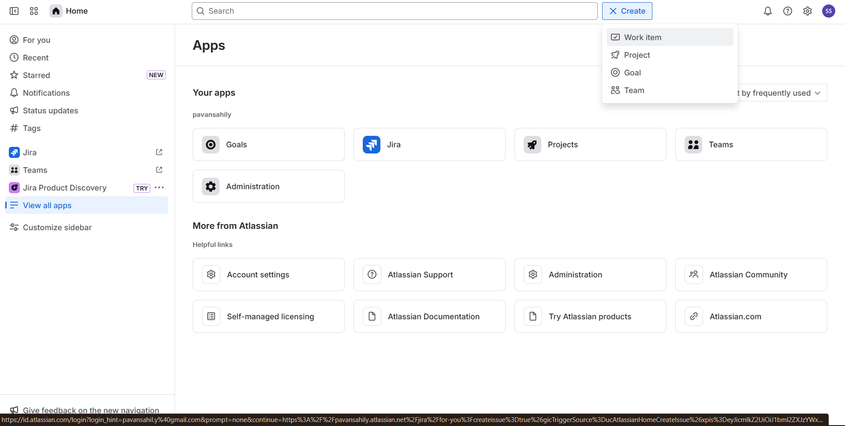

- Then we redirect it into this page.
- Assign ‘space’.
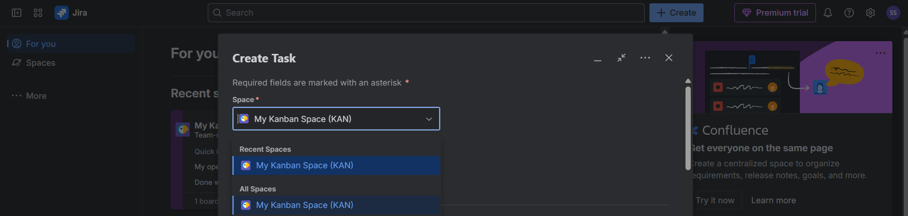
- Assign ‘work type’.
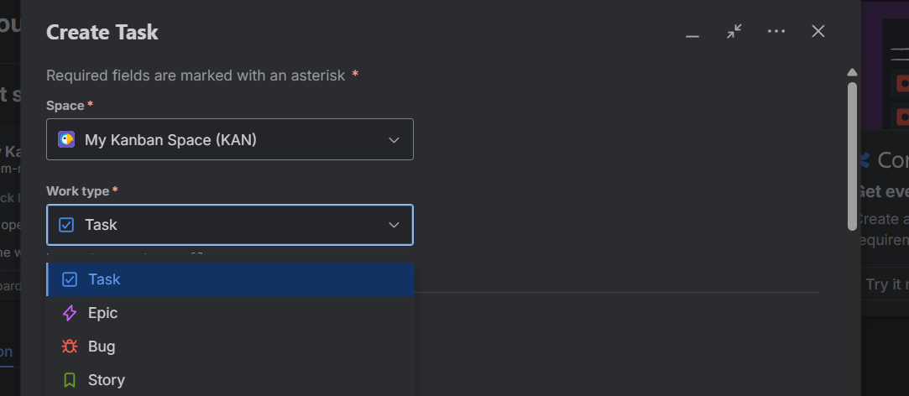
- Assign ‘status’
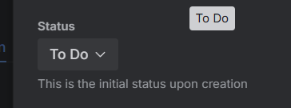
- Give summary for the task.
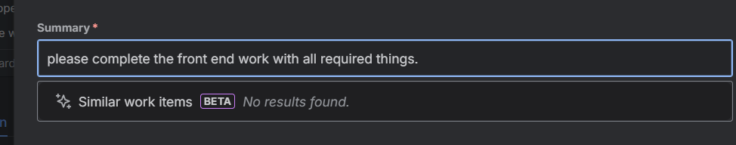
- add assignee from the list.
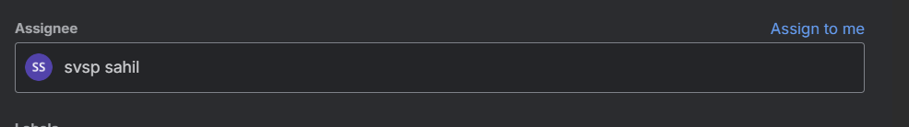
- mention due date
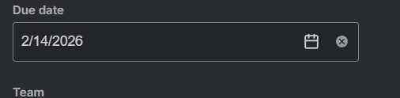
- assign team to the task
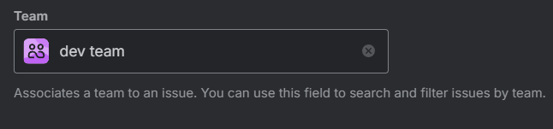
- mention start date and mention the reporter also
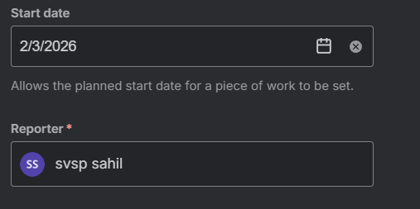
- here we finally created and assigned one task to the team.
